How to use a grid-tie inverter for AC-Coupling?

AC Coupling is a term used to describe systems that combine grid-tie inverters (usually feeding all energy produced to the grid) and battery-based inverters (usually for off-grid or backup applications).
Grid-tie inverters or solar inverters convert the variable direct current (DC) output of a photovoltaic (PV) solar panels into a utility frequency alternating current (AC) that can be fed into a commercial electrical grid or be used by a local, off-grid electrical network. A grid-tie inverter synchronizes with an existing sine wave (grid) and shuts down upon a grid failure.
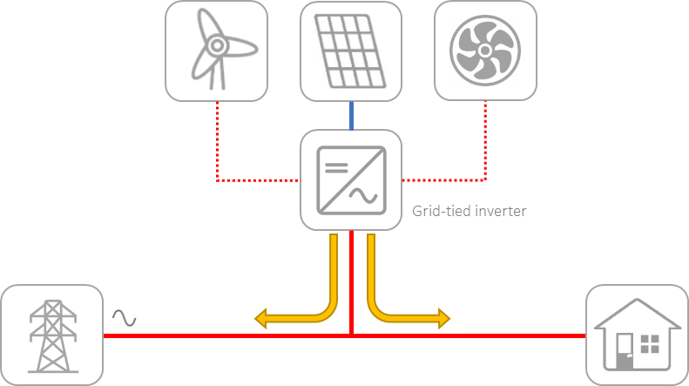
Today many manufacturers have included "frequency shift" behaviour on their grid-tie inverters. This allows the grid-tie inverters to reduce their power output depending on the grid frequency.
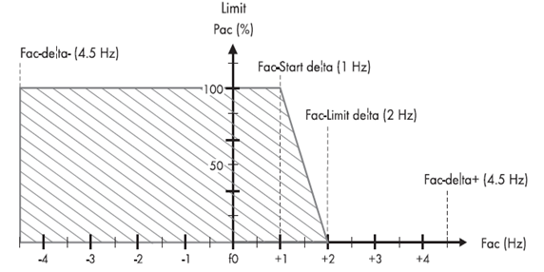
One or various solar grid-tie inverters can be installed in an Xtender system, coupled on AC. The system will work as described below:
1) AC Coupling with a Xtender Off-grid system
When off-grid, the Xtender is forming the grid with energy from the battery, using the inverter function. In this case, a solar inverter can be connected on the AC output of the Xtender. It will synchronize with the grid created by the Xtender and will feed its solar production into the grid to supply the loads and charge the battery.
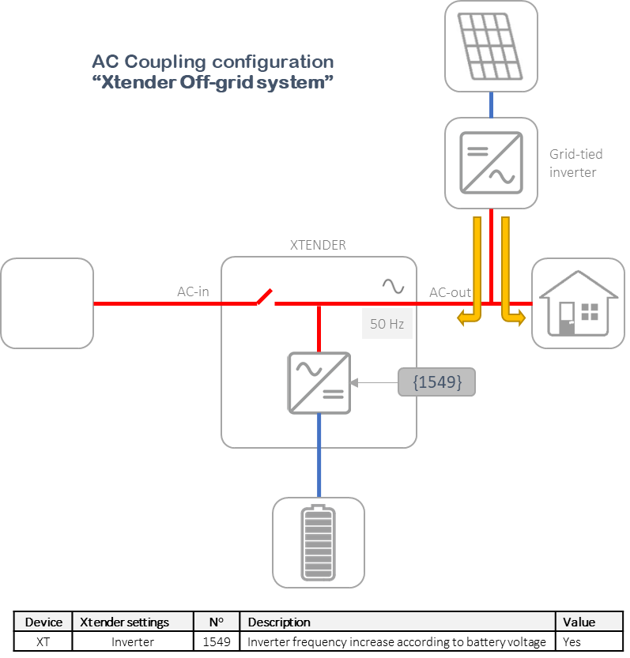
When there is an excess of solar production and the batteries are full, the system will need to limit the solar production. We can use the frequency control function from the Xtender, that will increase the frequency of the AC output according to the battery voltage. When the battery is fully charged, the solar inverter will stop its production, thus both the battery and the system are perfectly secured.
The frequency control function is activated by setting the parameter {1549} "Inverter frequency increase according to battery voltage" to YES.
2) AC Coupling with an Xtender connected to the grid
When connected to the grid, the Xtender will synchronize with it and close the transfer relay. In this case the Xtender acts as a current source inverter. Both the voltage and frequency are set by the grid and the Xtender synchronizes with them and exchange current.
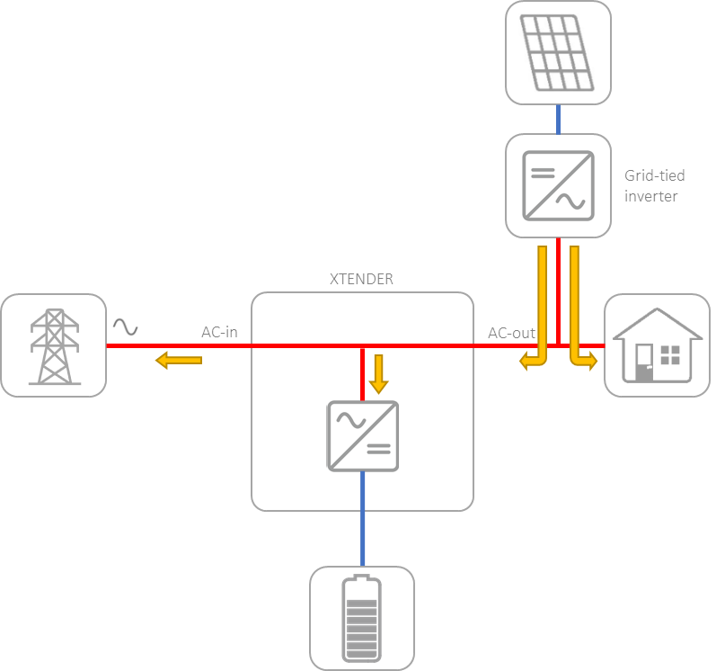

The solar inverter connected in the system, will feed solar energy that will be used directly by the loads and to charge the battery through the Xtender. In this case, the Xtender can't do any frequency control (the grid is controlling the frequency), therefore, the excess of solar production from the solar inverter will be then fed into the grid.
3) AC Coupling with an Xtender connected to a generator
Similarly, as when the Xtender is connected to the grid, the Xtender connected to a generator will synchronize with it and close the transfer relay. Again, both the voltage and frequency are set by the grid and the Xtender synchronizes with them and exchange current.
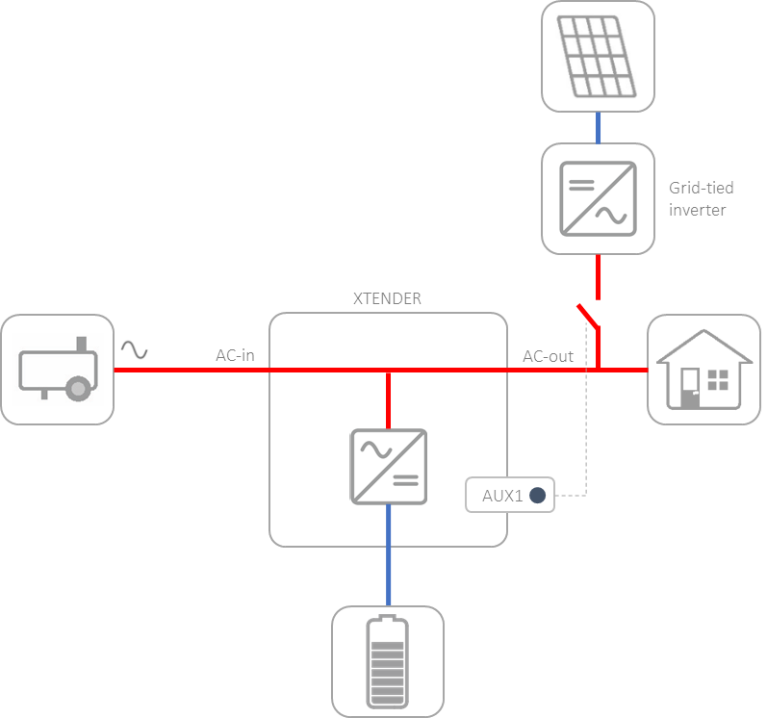

The main limitation of this situation is that it is not possible to feed energy back to the generator, as it will damage the machine. For safety reasons, it is recommended to use the Xtender's Auxiliary contact to open a circuit-breaker isolating the solar inverter from the Xtender inverter when the generator is working. During times when the generator is not used, the system will work as described in the off-grid situation (1).
AC Coupling with Lithium batteries
To enable control of a solar inverter connected on AC-Out with frequency shifting by the Xtender in off-grid mode, parameter {6072} must be set to “Yes”. This gives access to two sub-parameters:
- the first {6073} defines the frequency delta from the user frequency (e.g. 50Hz) at which the power derating of the solar inverter begins,
- the second {6074} defines the frequency delta from the user frequency at which the power derating of the solar inverter reach 100%.
The frequency shifting is performed according to the maximum charging current allowed by the Lithium battery.
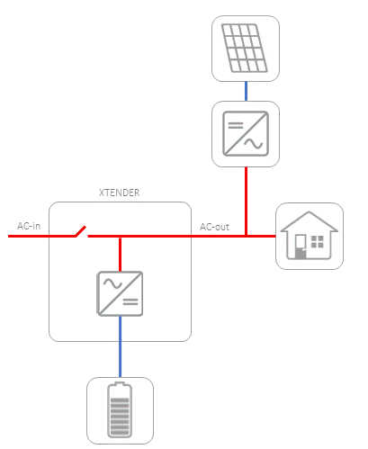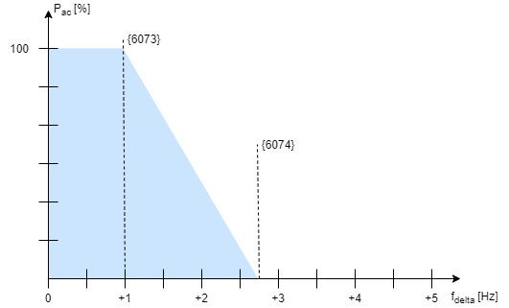
{6073} has a default value of 1.0 Hz, which makes the frequency to start derating equals to 51 Hz.
{6074} has a default value of 2.7 Hz, which makes the frequency to reach 100% derating equals to 52.7 Hz.
A third parameter {6086} allows to prioritize the ac-coupling instead of the solar charger energy in off-grid mode only. When the ac-coupling produces enough energy to match the battery required charging current, the solar chargers stops producing and only the solar inverter is regulated.

