JV 10125 Wp 11.5 MWh /Y
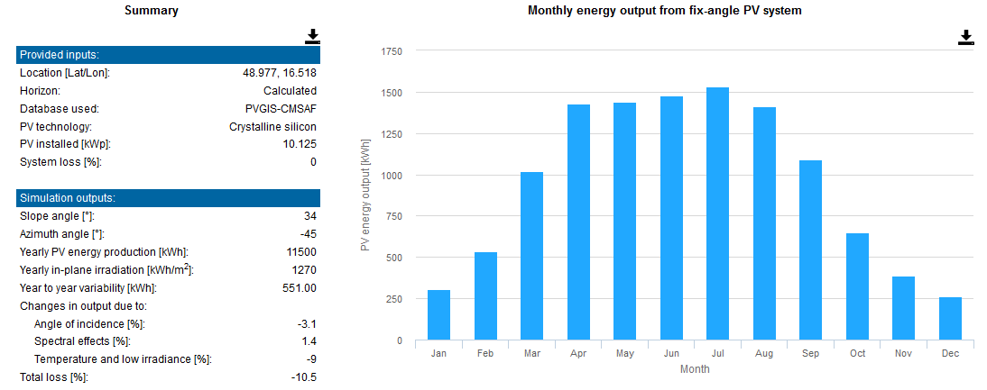
JZ 2250 Wp 2.5 MWh /Y
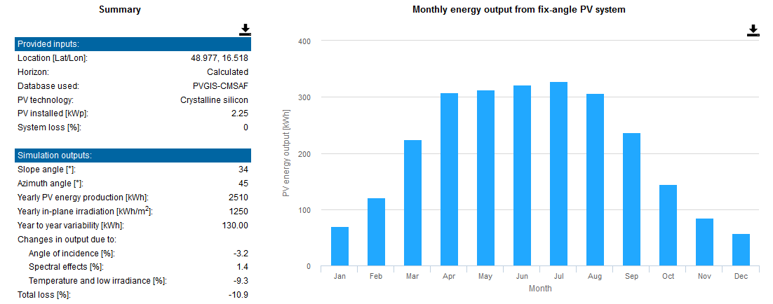
JZ 1125 Wp 1.2 MWh /Y


